**Top 10 Mobile Soccer Games**

**Soccer is the name of European football that is one of the topmost popular sports across the globe. With several teams, hundreds of players and millions of fans, soccer had acquired a top status in the gaming industry. Due to the flourishing number of fans and admiration, Soccer games are also popular among mobile and PC games. Gamers across the globe spend hours engaged with these games, and some of them are even the topmost grossing applications too. With realistic and abstract based concepts, all the variances in soccer are equally popular.**

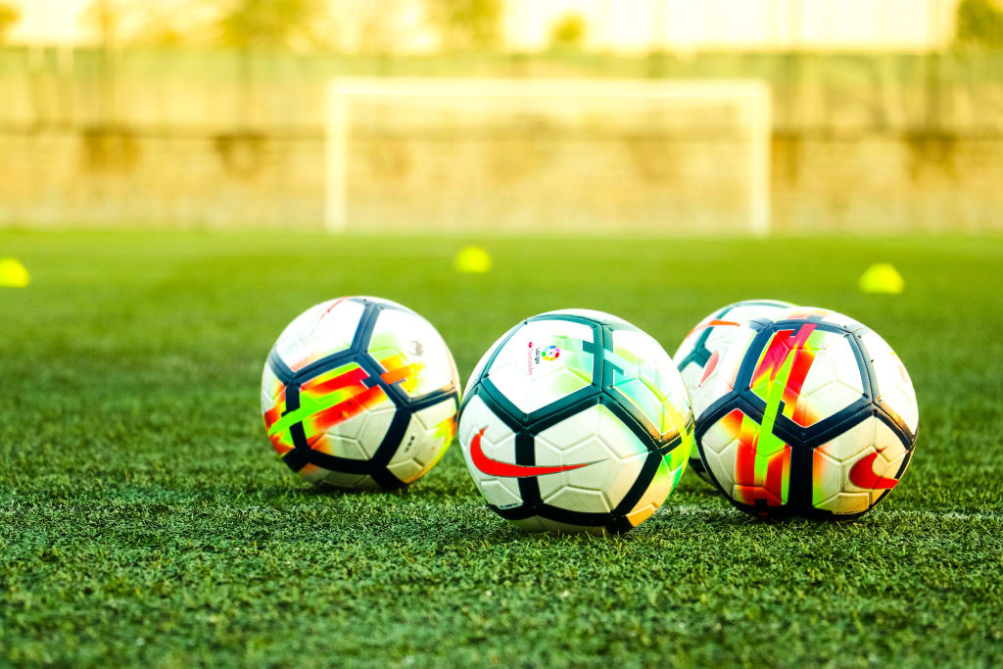

**Are you confused between the choice to go for the best soccer game for the most entertaining experiences?**

**Here are the top 10 soccer games available for mobile devices:**

**Stick man soccer 3D**

Stick man soccer 3D game is less serious and more arcade based. As the name suggests, the players are the stick man characters in this game. You can play with the club and earn the in-game currencies, from that currency you can buy the stick players with more skills, and with that, you can also customize your team and players. This game has a decent UI and allows making the personalized content and thus ensures higher entertainment.

**Soccer cup 2020**

Soccer cup 2020, this game has a realistic graphics with great animations and player movements, but sometimes the mechanics of ball is bit odd because the ball is sometimes stuck with the players’ feet or with the goalkeeper’s gloves. This game is pretty hard and thus ensures higher engagement. If you don’t know how to play this game, don’t worry, as this game provides you the best tutorial to tell you how to play. In this game, you can also play with players like Messi and Ronaldo and also with the great teams like Spain, Brazil, Argentina, etc.

**Score! Hero**

This game takes out all the boring parts of soccer playing and provides you the scoring opportunities. This game provides you more than 700 challenges! From corners and mid of the ground you can pass and play if you want to, this game also provides training opportunities to make the gameplay easier. This game ensures higher sensitivity with the touch and thus each strike results in better outcomes. The graphics of this game are realistic and animations are amazing, and also if your opponent makes foul, you were provided penalty shoot-outs.

**FIFA football**

This game used all the real players and real teams. EA always pushed a bit too much to the marketing side and it seems that the game revolves mostly around opening packs and always acquired better players. This game has amazing and realistic graphics and has great animations that can surprise you. You can choose your team on your own and buy players with amazing skills with the money that you get from the gameplay. The better the team you have makes the situation of winning the game much easier. Also, several types of modes are provided by the game and this game has ranked in the top 5 grossing games too.

**Soccer stars**

This game is not like the other soccer games, as in this you do not play with character players you have to play with strikers and hit the soccer to make a goal! This game is multiplayer games in which the players come from many countries are enrolled for higher entertainment. This game has amazing graphics too and you can win the game and collect the score amounts in this too. With the earned amount, the players can buy new strikers with attractive prints. Several types of modes are also there in this game, such as tournaments, championships, campaigns, etc. If your money has vanished, for that daily spin is there, you can also earn from there and continue the gameplay. The game has 50 million + downloads and it has 4.2 ratings and that shows how amazing the game might be!

**Extreme football**

The game’s graphics, animation, and all the features are too amazing. Forgot the gardens and playground, as this game takes you to your childhood days when you used to play in the streets. You can play this game with your friends, and the game has pretty easy consoles too. You can collect the in-game money and chase your opponents with this game. You can play this game as 1v1, 2v2, 3v3, so you don’t need many other people to enjoy this game. The rating of this game is 4-stars and it also has 1million+ downloads. The player characters have the exclusive skill and the amazing part is that game provides you the training part to practice the skills and know the skills of different players.

**Dream league soccer 2020**

In this game, the graphics are very amazing, and this game includes plenty of license players. The movements are smooth and realistic too. The size of this game is too large for the low memorable devices but if you have a good device you should enjoy the game and its graphics. This game has more than 10 million+ downloads and the rating of this game is 4.1 out of 5, and this game is under the top 10 grossing games. In this game, you can also choose the captain that you like and also select the name of your manager for the team. This game also provides an engaging background soundtrack.

**Football strike**

This game has amazing graphics and animation. This is an addictive game with extraordinary features and several modes like shooting race, free kicks, career, etc. The game is highly admirable among its players and has a 4.3-star rating out of 5, and it is also in the top 10 free games. The game also has a high number of downloads which is more than 100 million. Overall game experience in this is highly entertaining and the soundtrack is pretty engaging too.

**Soccer star 2020 top leagues**

The game is much amazing and one must experience its graphics, animations, modes, etc. You have to conquer all the leagues in the game, and you must have to score amazing goals to win against your opponents. People can play this game and compete against anyone from worldwide, they can also play with their friends and colleagues and get a good online ranking with each winning. The new 2020 update came with 200 new levels of training. The game has 10 million+ downloads and a giant fan base.

**E football PES 2020**

The game is for the ones who want amazing graphics. However, the game has a huge memory size that is 1.6GB and it also has 50 million + downloads. This game is admired a lot and has 4.3-star ratings out of 5. It also comes under the top-grossing mobile games. This game has several types of modes and you can also play with players like famous Messi. In this, the players can play and win tournaments and championships and receive the trophies too.

**Soccer game app development**

Game App studio provides the best app development services, and game developments are the most satisfying services offered by us. We embed the best services in the application regarding the game and its genre, and from real to animated graphics, we excel in everything. We also provide the best consoles and soundtracks, and the games developed are smooth and error-free too. We work to meet the client requirements and provide the best-blended app with many services.